Open Call For Detroit Based Singer/Songwriters, Lyricists, and Music Producers
Boa Me: A Community Songwriting Project

Motor City Sings is currently searching for Detroit based singer/songwriters, lyricists, and music producers who identify as Black/African American to join our summer artists collective for Boa Me: A Community Songwriting Project. Each artist collective will work with a research team to learn how Black Detroiters have navigated the last two years of the global pandemic. After observing community discussions, each collective will then work together to compose new original music inspired by the research findings.

All roles will be compensated. Application closes on June 17th. Interested applicants can apply and learn more at www.motorcitysings.com. Questions can be sent to motorcitysings@gmail.com Subject Line: BOA ME QUESTION.

“Boa Me” is an abbreviation of the West African adinkra symbol BOA ME NA ME MMOA WO, which translates to English as “Help Me, and Let Me Help You”. The symbol encompasses the principles of healthy interdependence, connection, and healing.
Founded in 2018, Motor City Sings is a 501(c)(3) nonprofit with an established history of partnering with local artists, community organizations, and mental health professionals to promote positive mental health and remove stigma from the subject of suicide prevention in the Black/African American community of Detroit through musical performance.
Rochelle Riley, director of Arts, Culture and Entrepreneurship for the city of Detroit lauded the group for working in a space and with a challenge that sometimes isn’t talked about in Black communities.
“A big part of recognizing all of the culture that exists in Detroit is to remember that much of our creative excellence also can help emotionally, physically, and spiritually,” she said.
On Friday July 1st, Motor City Sings will kick off the project in a live musical concert called: Motor City Singers' Space Unplugged: Boa Me Begins featuring acoustic musical performances by several special guests. The talent line up for July 1st includes Johdi, Kenny Watson, Trey Simon, La Shaun phoenix Moore, Natasha T. Miller, Charity and more. This event will also feature the infamous Motor City Singers’ Space audience interaction and provide details on how community members can both volunteer for incentivized positions to be involved with this important community musical mental health initiative. The concert is scheduled to occur on Friday July 1st, 2022, from 6:00pm -8:00pm in the Dequindre Cut Freight Yard at Dequindre Cut Greenway, Detroit, MI 48207
Program curator Ben Will states “The overall goal of this project is to help Detroiters, (and specifically Black Detroiters) reconnect and create agency while developing new music that encompasses the shared sentiments, stories, and emotions of surviving a global pandemic”.
Admission for July 1st is free, all guests must register to enter event.
For more information about the open call or event on July 1st please visit www.motorcitysings.com
###
Press and Media Contact
Ben Will (motorcitysings.com)
(313) 399-1733
motorcitysings@gmail.com

(Open Call Info)
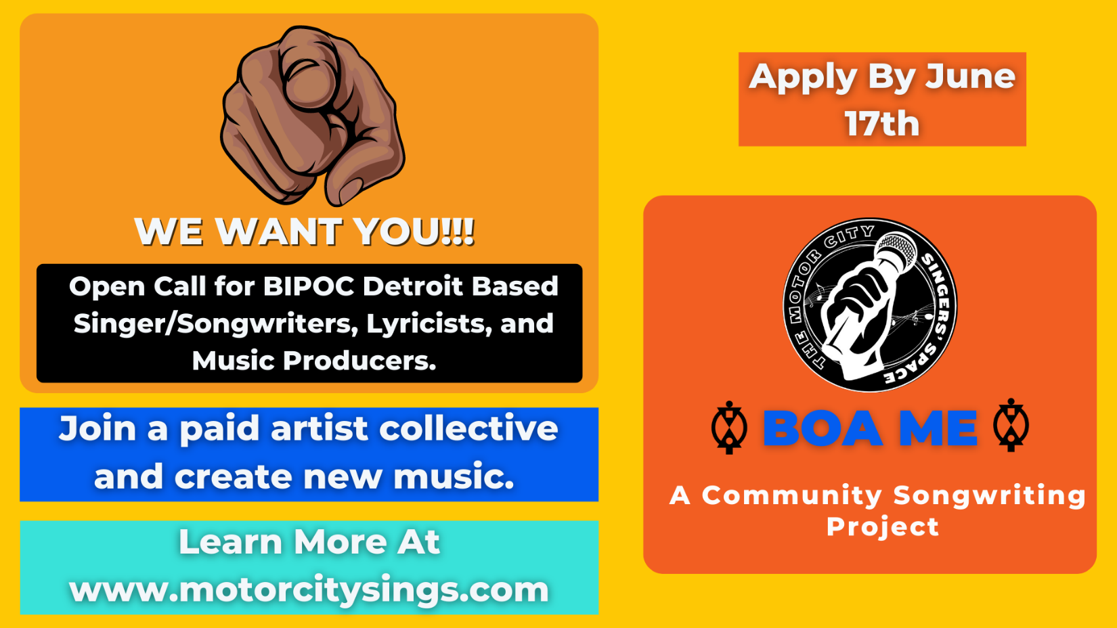

Motor City Sings is currently searching for Detroit based singer/songwriters, lyricists, and music producers who identify as Black/African American to join our summer artists collective for Boa Me: A Community Songwriting Project. Each artist collective will work with a research team to learn how Black Detroiters have navigated the last two years of the global pandemic. After observing community discussions, each collective will then work together to compose new original music inspired by the research findings.

All roles will be compensated. Application closes on June 17th. Interested applicants can apply and learn more at www.motorcitysings.com. Questions can be sent to motorcitysings@gmail.com Subject Line: BOA ME QUESTION.

July 1st Event Photo
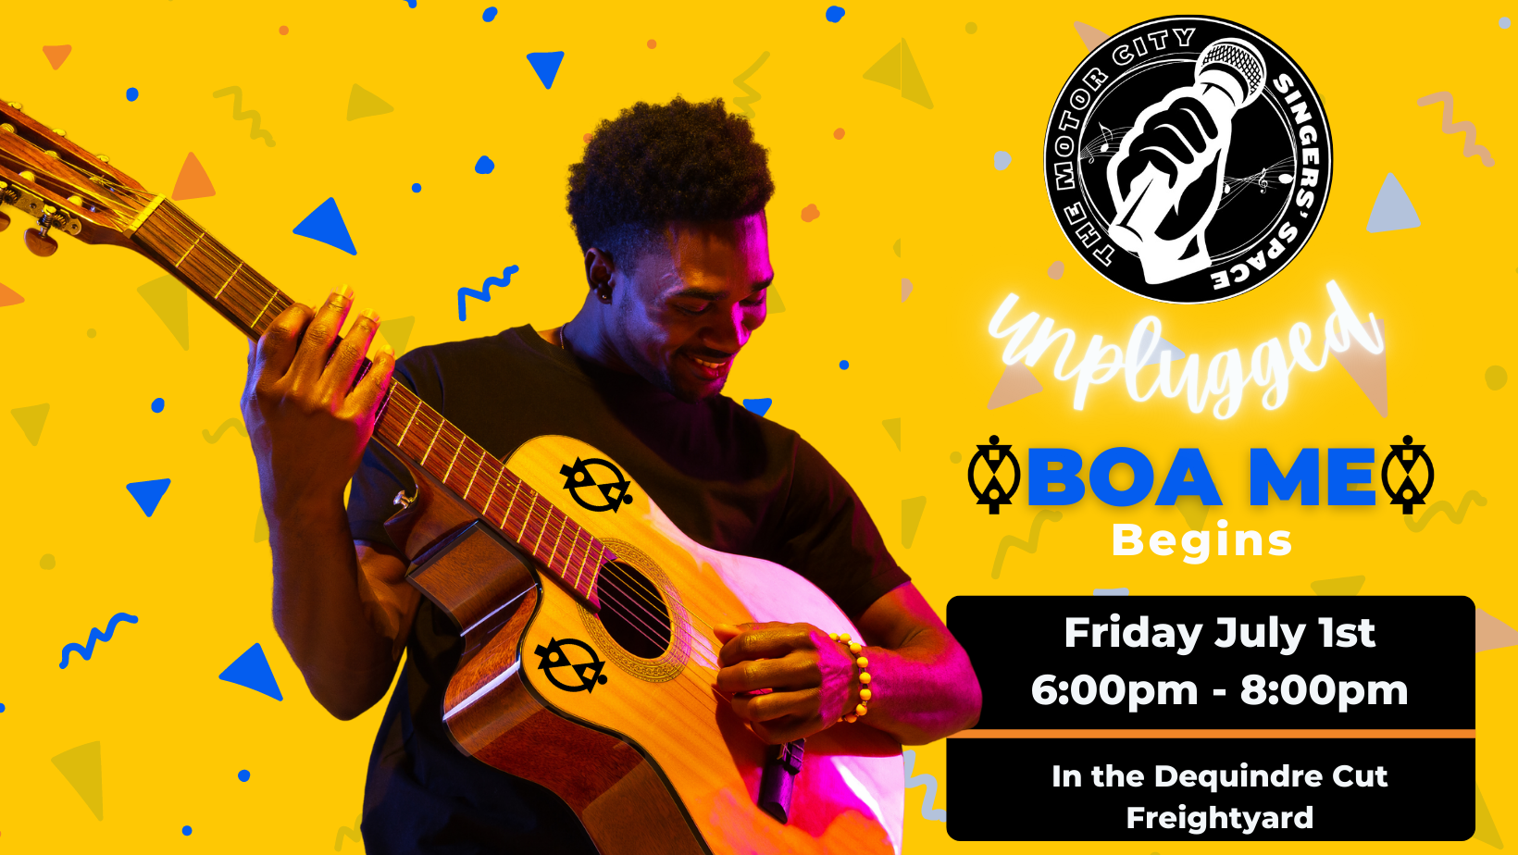
(July 1st General Event Photo)
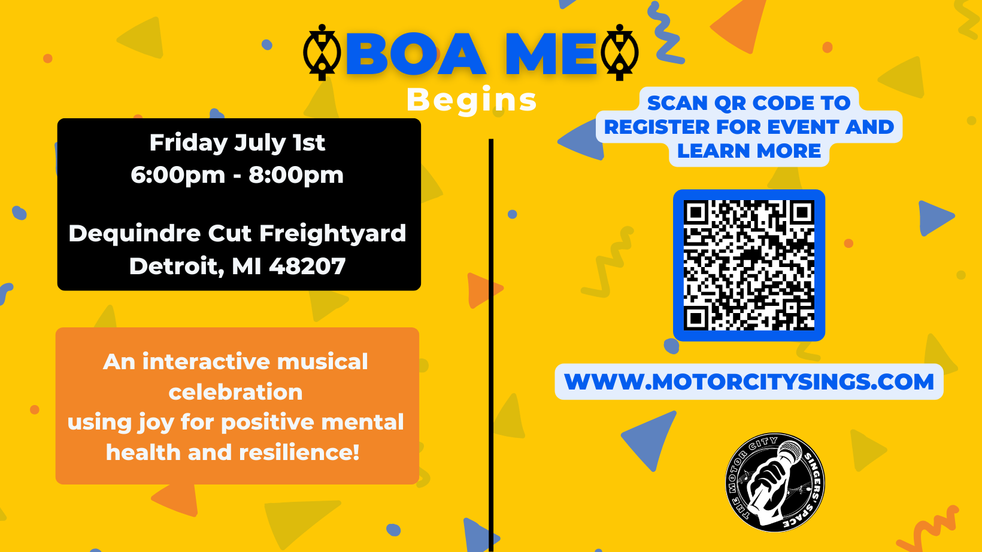
(July 1st Event Photo)
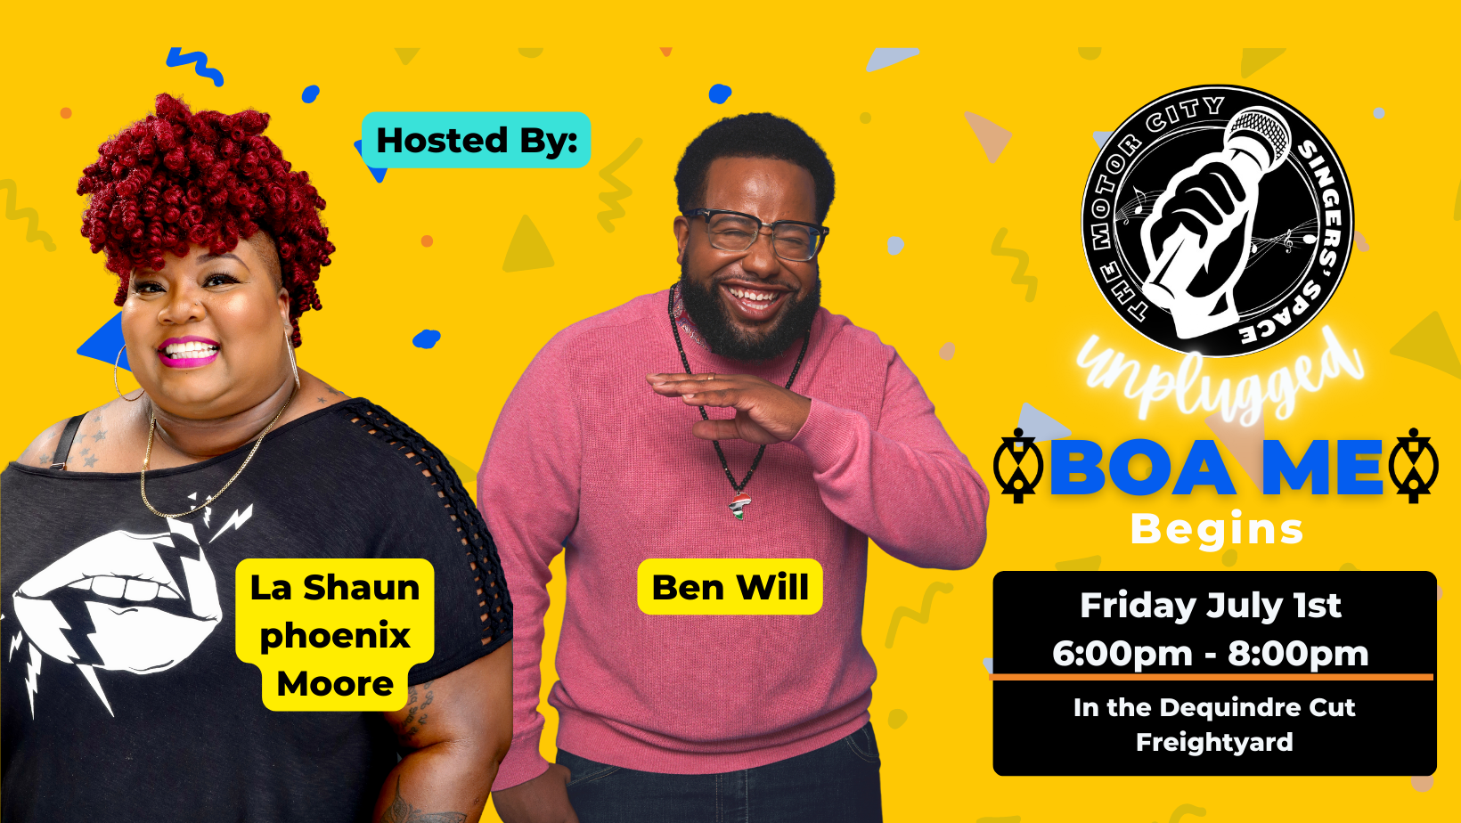
(July 1st Event Hosts)
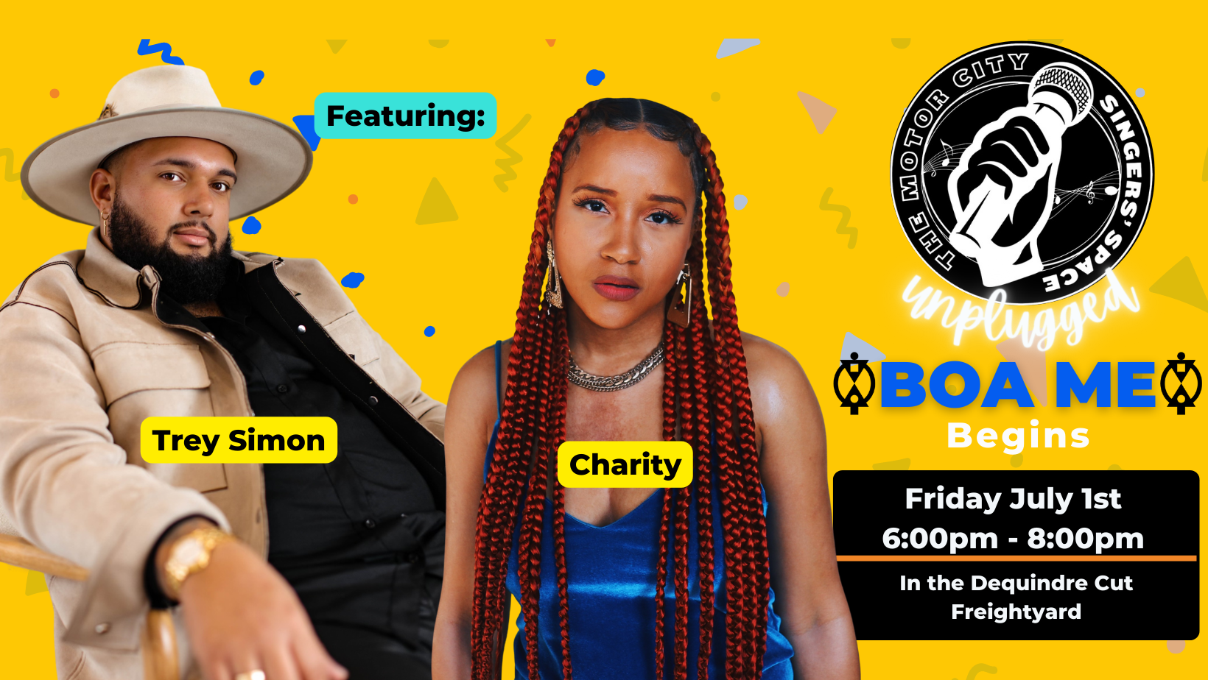
(July 1st Event Photo with Artists Trey Simon & Charity)
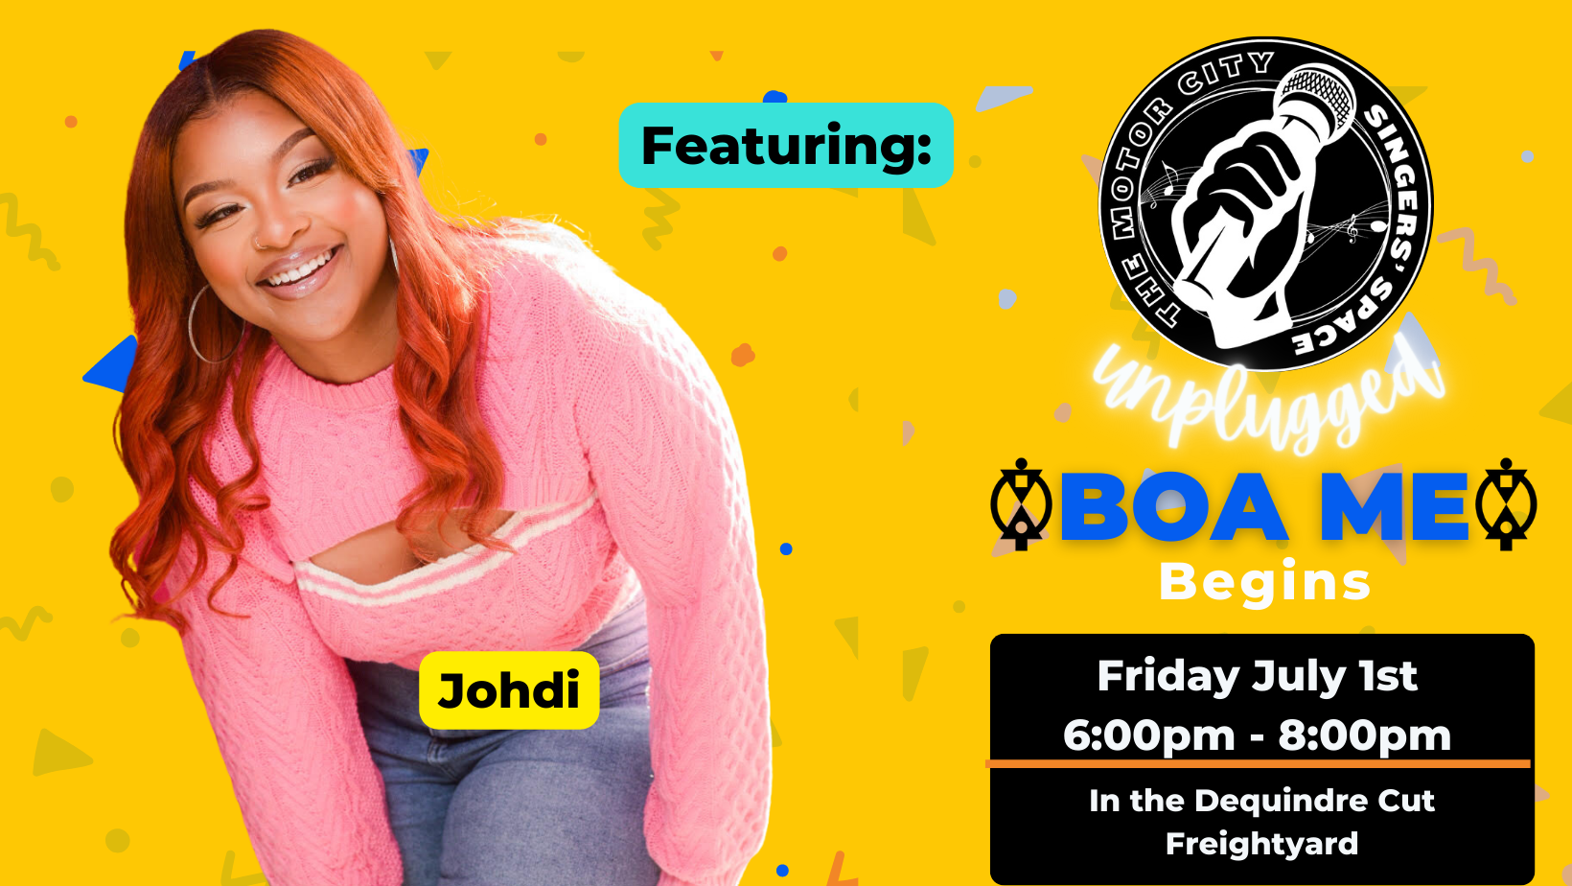
(July 1st Event Photo with Johdi)

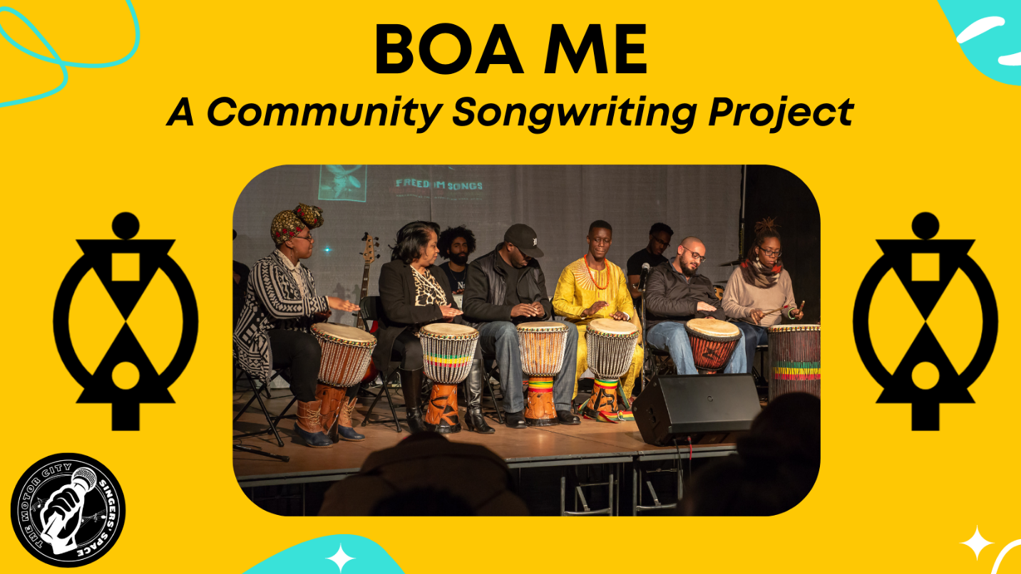
(Full Project Photo)

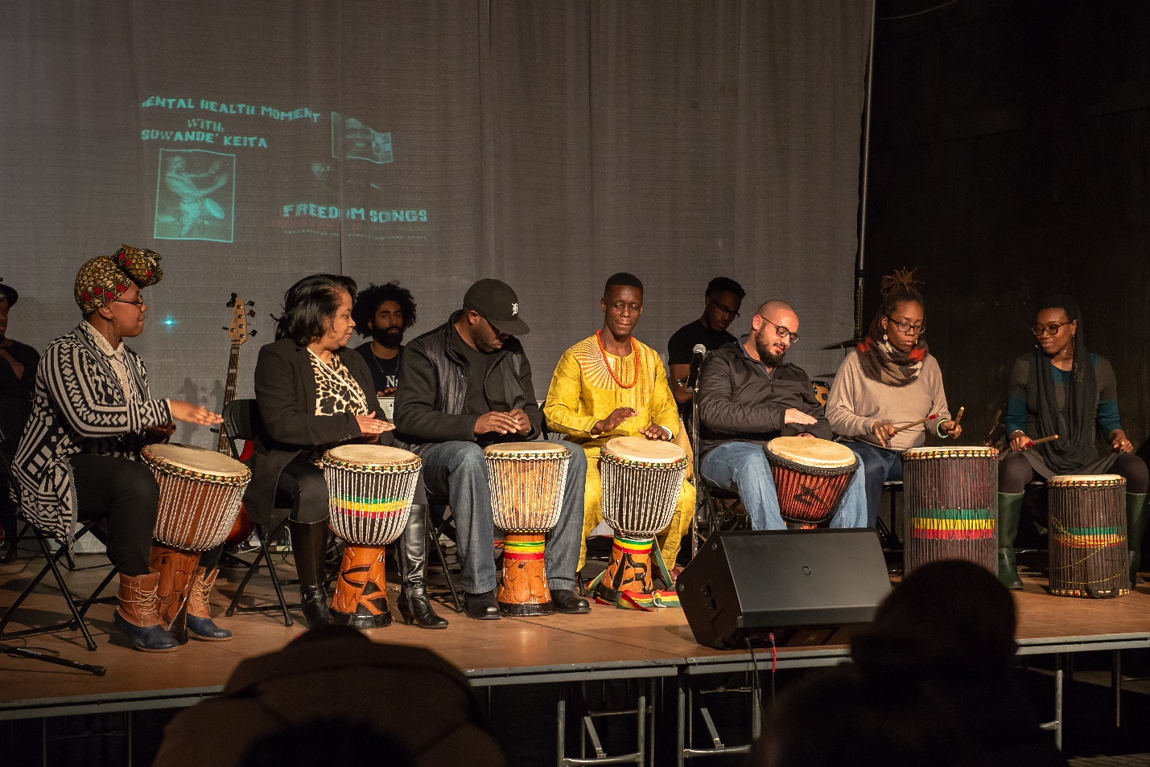
(Boa Me Press Image without Formatting)

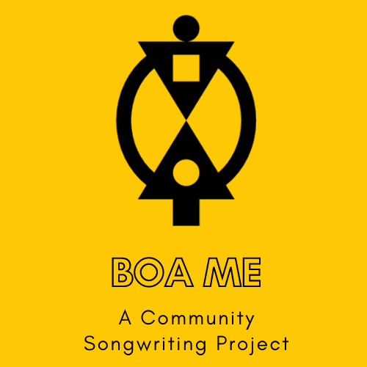
(Boa Me Logo)

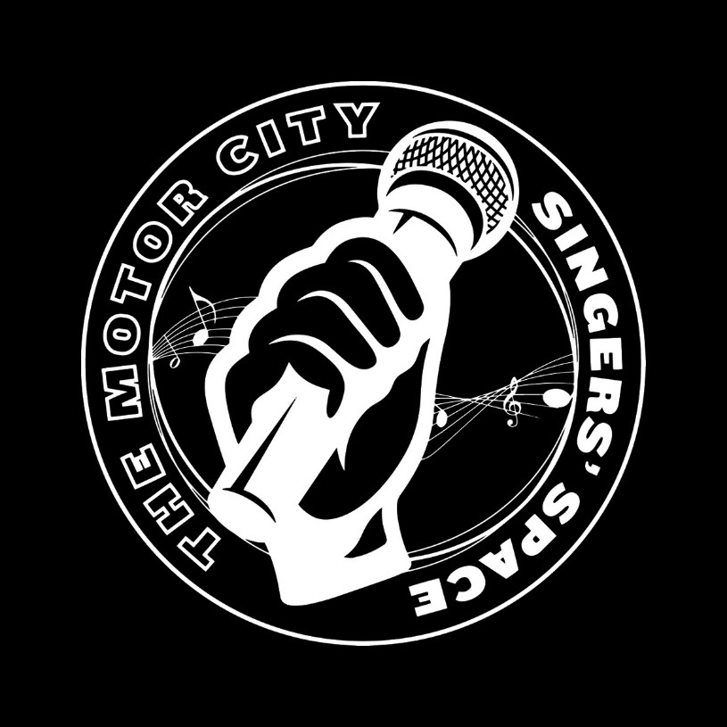
(Motor City Singers’ Space Logo)

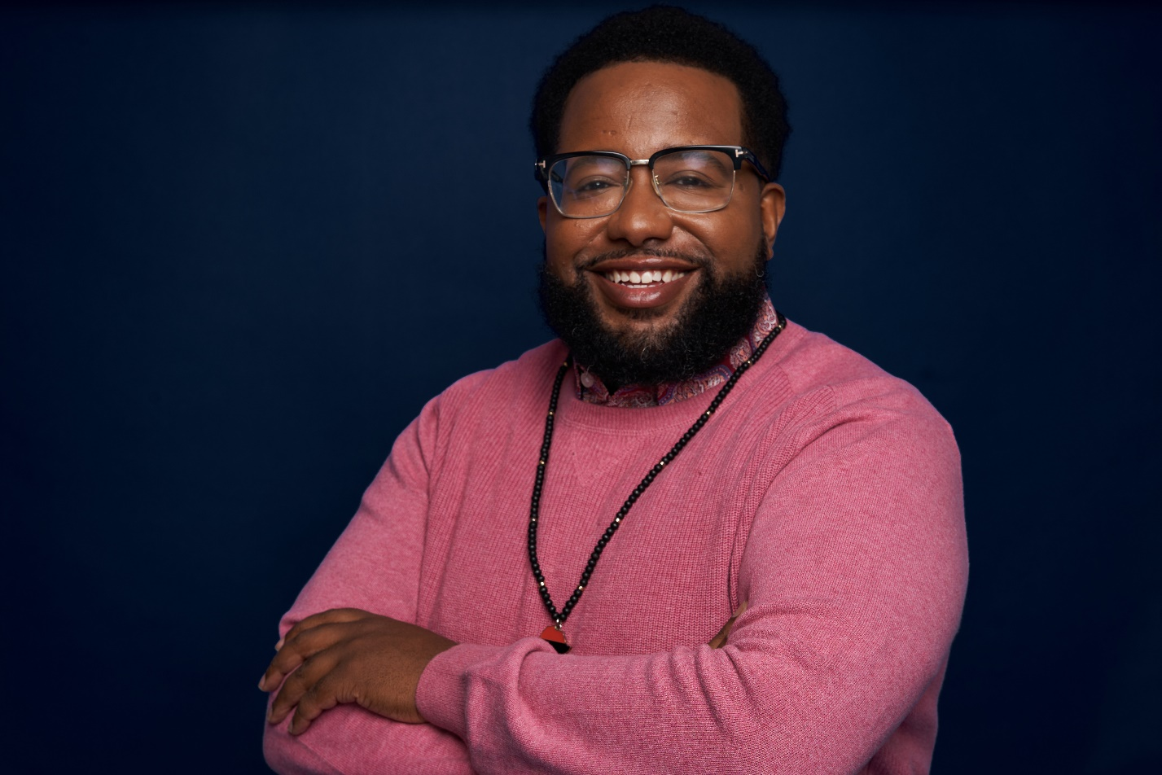
(Event Curator: Ben Will)
Ben Will is a singer/songwriter/poet, mental health advocate, and cultural curator native to Detroit, MI. He is also the executive director of Motor City Sings a 501(c)3 non-profit organization that utilizes musical performance to remove stigma from the topics of mental health and suicide prevention within the Black/African American community of Detroit.
Born on Detroit’s eastside, Ben has been making art his entire life. Ben immersed himself in music and performance from his early studies of voice and theatre as a Mosaic Singer and Renaissance High School Varsity Chorus member to studying arts and sciences at Cornell University, New York University, University of Detroit Mercy and Wayne State University. As a performer, notable artists Ben has shared the stage with include: Rupi Kaur, la shaun PHOENIX moore, Al Green, Sweet Honey in the Rock, Jonathan McReynolds, Pete Seeger, and Detroit's own Alvin Waddles. As an International Cultural Ambassador with the US Bureau of Educational and Cultural Affairs Ben produces music and cultural events such as The Motor City Singers’ Space, The HAM Slam, WordPlay and Boa Me: A Community Songwriting Project. Ben was also recently lauded as the 2022 Motown Mic Spoken Word Artist of the Year.

Co-Host/Co-Producer
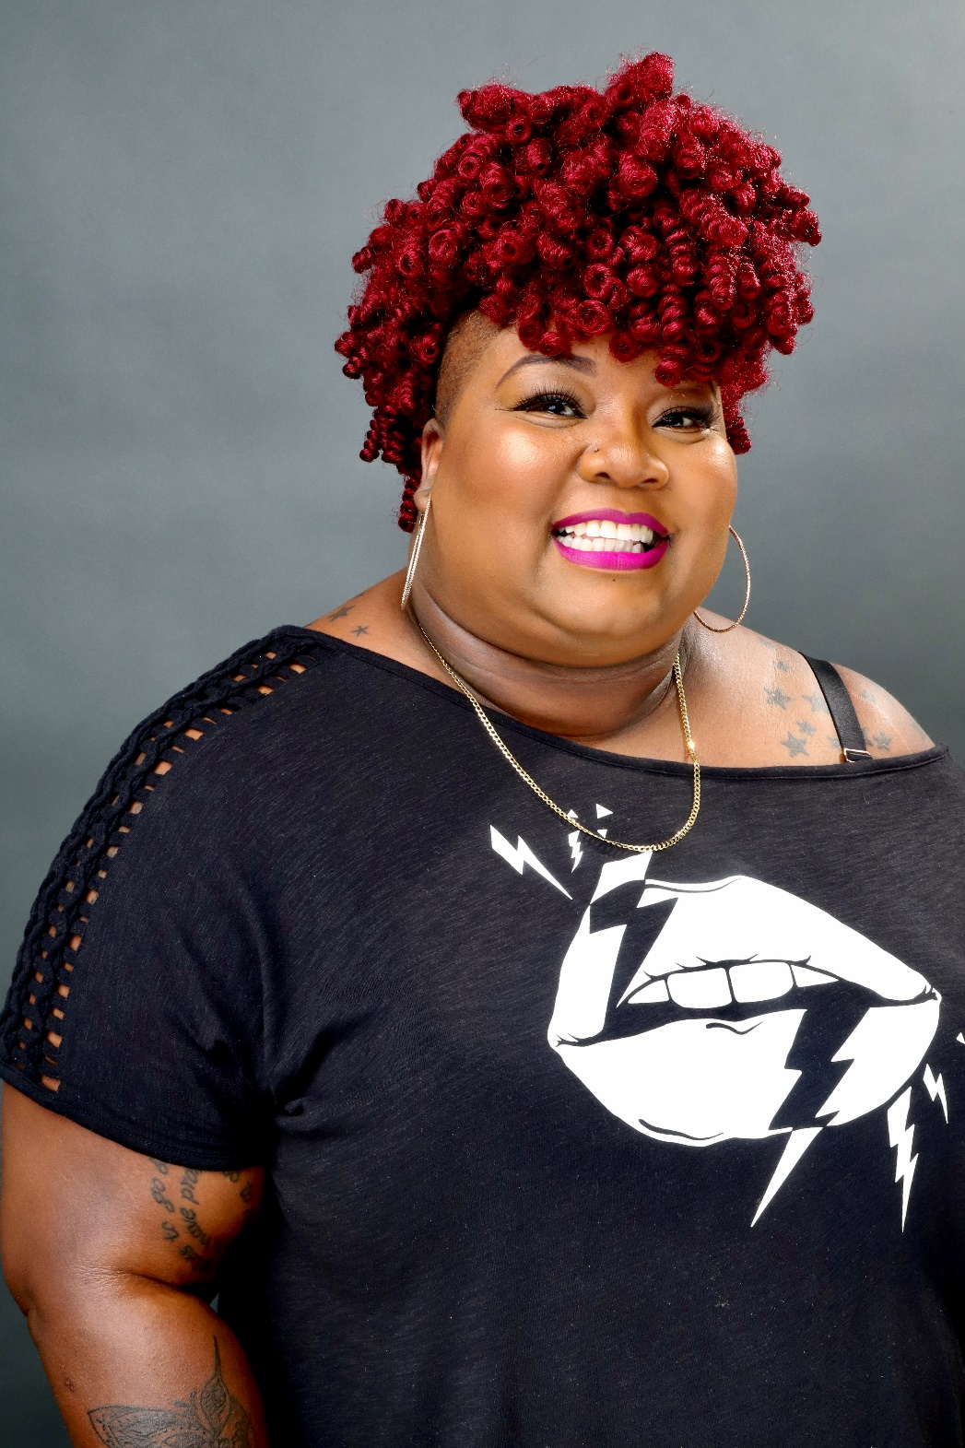
Co-Host/Co-Producer (La Shaun phoenix Moore)
La Shaun phoenix Moore is a Detroit-based vocalist, spoken word artist, activist, culture creator and wife. Moore’s interdisciplinary work is infused with her love for the city of Detroit, hip-hop, God, social justice and her black momma. She is currently working on her first memoir exploring the complexities of the Mother Wound and how it is rooted in her immediate family. Moore is the coach of the Youth Performance Troupe for InsideOut Literary Arts. She is the recipient of the 2020 and 2021 Creators of Culture Award by CultureSource

Featured Performers
(Performer: Johdi)
Johdi was born and raised on the Westside of Detroit MI. She started singing at just 2 years old and discovered her love and passion for music at the young age of 7 years old. Her musical inspirations include Aretha Franklin, Whitney Houston, Jasmine Sullivan, and Beyoncé of course. Johdi has performed on many stages and has opened for many great names such as The Jackson’s, Dru Hill, Eric Benet, Morris Day, Avery Sunshine, Vivian Green, and Maimouna Youssef (MuMu Fresh). Her latest project Stupid Girl EP and singles 24 Hours and Too Good are available everywhere for streaming and purchasing!

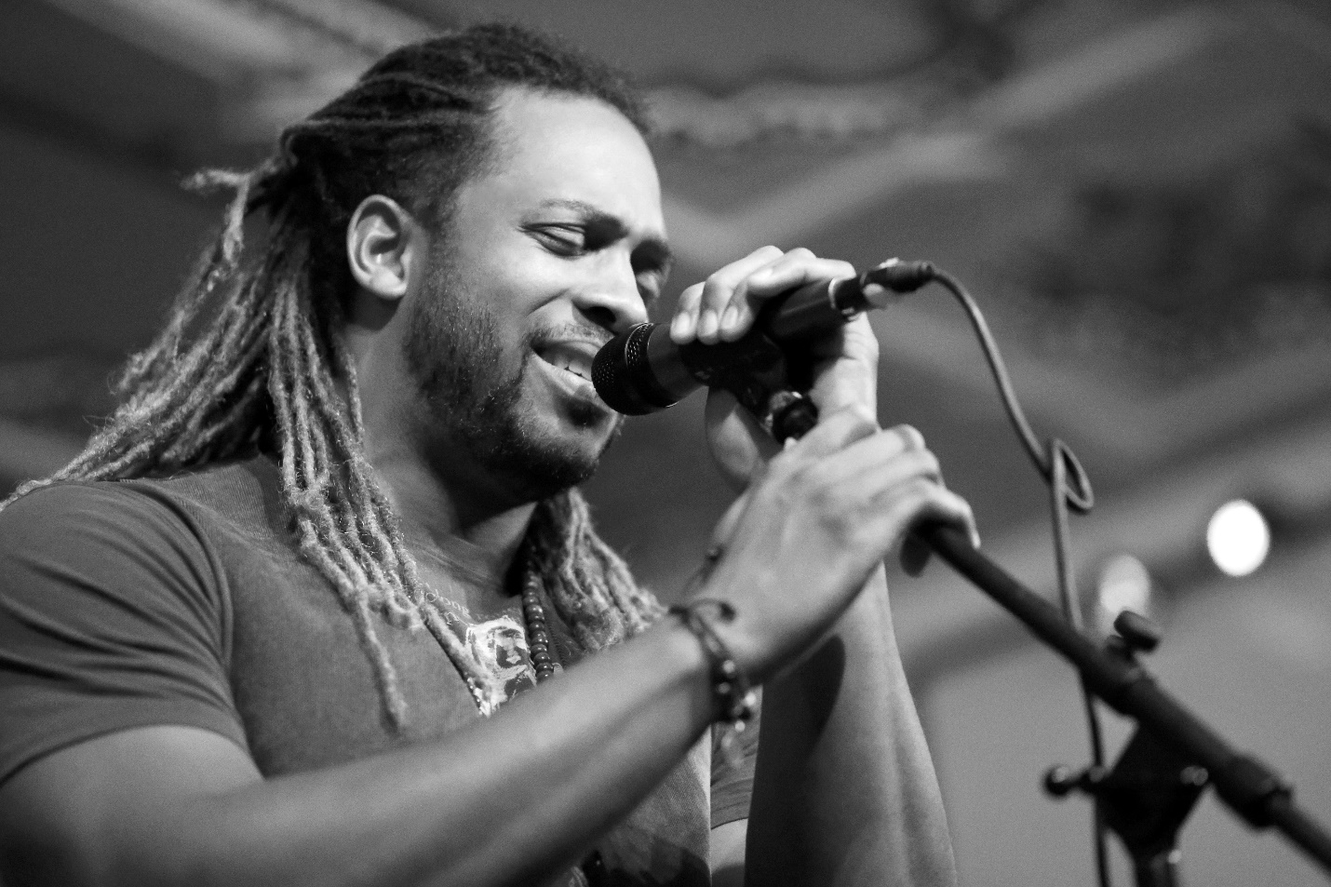
(Performer: Kenny Watson)
Kenny Watson, a Motor City native, is carved out of musical excellence and is equipped with the message of love for one's self and community . He humbly garnishes the versatility of refined vocals that span across the genres of R&B, Jazz, Classical and Pop and Broadway style plays.

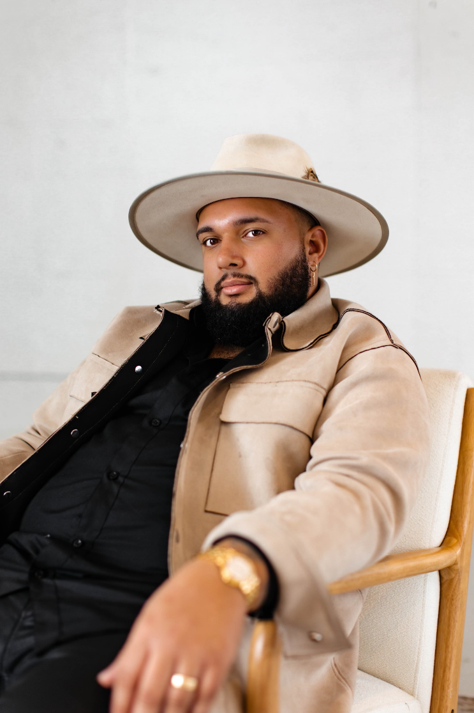
(Performer: Trey Simon)
Happening upon his grandfather’s Gibson under his uncle’s bed, Trey Simon’s musical journey began. At age 12, he had started music lessons and began his first band as he fell entranced by how one could embody passion using sound. Performing in open mics and continually honing his songwriting abilities eventually grew into touring across the country and even opening for big names like Patti LaBelle, Andra Day, and Andy Grammer.

With influences from both old blues musicians and singer-songwriter genres, Trey’s style is a mix of dynamic vocals and impassioned honesty. Trey is vulnerable and transparent about his experiences, which allows him to connect to his listeners in personal and powerful ways. His steady voice digs into the ear while his lyricism reveals something precious and careful about who he loves and how he hurts, and what hope he clings to.
His newest singles The Impossible and When the Lights Turn On are available on all streaming platforms.
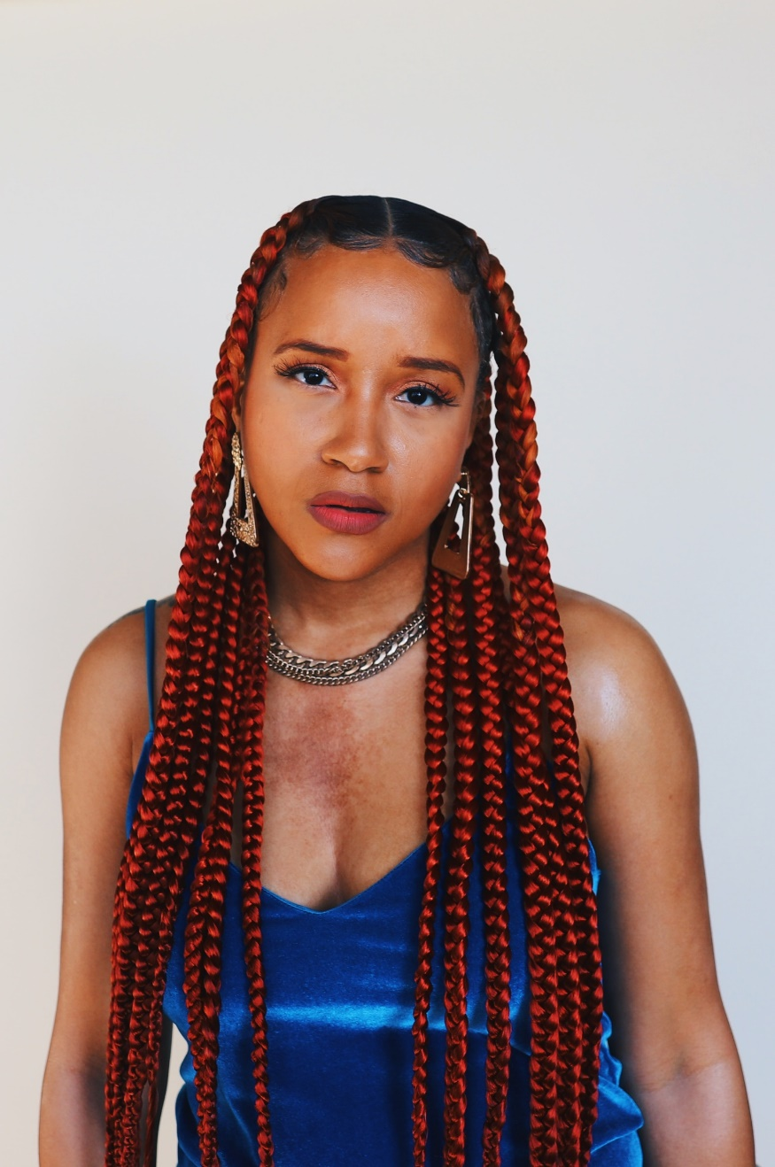
(Performer: Charity)
Over guitar-led melodies, 808 beats and churchy organ riffs, singer/songwriter Charity delivers a genre defying fusion of R&B, Neo-Soul and Hip-Hop. A Detroit native and enthusiast, and graduate of historically black college, Tennessee State University, Charity’s originals make the listener feel seen and strong. Drawing inspiration from artists like Stevie Wonder, Lauryn Hill and Frank Ocean, she pens and performs songs that combine musical storytelling with captivating messages for a generation. Her debut album Tender Headed is a of blend reflective ballads and upbeat anthems that narrate elements of love, empowerment and the millennial experience. Taking the listener through a journey of brokenness and healing while exposing her strong opinions on fidelity, culture, religion, marriage, and independence, Charity describes Tender Headed as a sonic space where women finally have permission to be both soft and strong at once.

